Fish Facility Design Review Work Group (FFDRWG)

USACE, Portland District

# March 2021 Meeting Agenda

March 4, 2021 09:00-11:00

Join Meeting: <https://usace1.webex.com/usace1/j.php?MTID=m5c365c1bf762dad74cbaa2985e8e04fb>

Meeting password: FFDRwG2021!

*(*if using your phone for audio, log in through Webex and have the meeting call you)*

Join by phone (audio only, no Webex): (844) 800-2712 | Access Code: 199 571 1422

## Introductions

Invited Attendees:

**BPA**

**\*****Scott Bettin**

Kim Johnson

Siena Lopez-Johnston

**\*Christine Petersen**

Greg Smith

**\*Leah Sullivan**

**NOAA**

**\*Blane Bellerud**

**\*Gabriel Brooks**

**\*Trevor Conder**

**\*Kinsey Frick**

Claire McGrath

Josie Thompson

**\*****Logan Negherbon**

**USFWS**

**\*****Dave Swank**

**States**

**\*****Erick Van Dyke (ODFW)**

**\*Charles Morrill (WDFW)**

**CRITFC/Tribes**

**\*Tom Lorz (CRITFC)**

Blaine Parker (CRITFC)

Tom Skiles (CRITFC)

Casey Baldwin (CTCR)

Michael Karnosh (CTGR)

Lawrence Schwabe (CTGR)

**\*Torey Wakeland (CTGR)**

Aaron Jackson (CTUIR)

Ralph Lampman (YN)

**NPCC**

Leslie Bach

Kris Homel

**FPC**

**\*Erin Cooper**

**PSMFC**

Alan Brower

Darren Chase

Roger Clark

Mark Leonard

Scott Livingston

Nicole Tancreto

**\*Don Warf**

**CENWD**

**\*Doug Baus**

Tim Dykstra

Dan Feil

Mike Langeslay

**\*Cindy Studebaker**

Sean Tackley

**\*Lisa Wright**

**CENWW**

Karl Anderson

**\*Chris Peery**

Marvin Shutters

**\*Denise Griffith**

**CENWP-OD**

Leif Halvorson

Ben Hausmann

Rebecca Cates

Jeanette Wendler

Bob Cordie

Jeffrey Randall

Scott Fielding

Eric Grosvenor

**\*Michael Lotspeich**

Erin Kovalchuk

Tammy Mackey

Darren Gallion

Nathan McClain

Robert Wertheimer

**CENWP-PM**

Jim Adams

Eric Bluhm

Ian Chane

**\*Andrew Derugin**

Jeff Hicks

Valerie Higdon

Steve Sipe

Bob Winters

Brad Eppard

David Griffith

Fenton Khan

Rachel Laird

**\*****Jake Macdonald**

Rich Piaskowski

**\*Jon Rerecich**

Ida Royer

David Trachtenbarg

Jeremiah Woodard

**CENWP-ENC**

**\*Adam White**

**\*Brandt Bannister**

Bridget Bell

Jonathon Brink-Roby

Shari Dunlop

Laurie Ebner

Curtis Lipski

Chris Motti

Stephen Schlenker

Max Wilson-Fey

**\*in attendance**

## Action items from last meeting

* None

## Written project updates

* JDA North Fish Ladder Variable Width Weir improvement – Eric Bluhm (PM), Eric Grosvenor (JDA), Jacob Macdonald (FC)

**Dave Swank (USFWS)** asked about the schedule. Construction in Winter 2021/2022 or Winter 2022/2023? **Jake Macdonald (NWP)** answered we’re still figuring out the scope of the improvement. If it’s an easy fix, we’ll install it during the next in-water work window. If it will require more engineering than we expect, we may need to postpone installation for a year. **Michael Lotspeich (NWP)** added that we’re expecting to use the same material as before so won’t require extensive engineering. It’s a safe bet we’ll get this done Winter 2021/2022, the schedule has been updated.

* JDA North Fish Ladder LPS water supply upgrade – Eric Bluhm (PM), Adam White (TL), Jacob Macdonald (FC)
* JDA turbine rehab – Steve Sipe (PM), Curtis Lipski (TL), Jon Rerecich (FC)
* TDA AWS Trash Rake – Ida Royer (PM), Erica Tarbox (TL), Ida Royer (FC)
* BON spillway rock removal [prevention] – Jeremiah Woodard (PM), Max Wilson-Fey/Chris Motti (TL), Ida Royer/Andrew Derugin (FC)

**Erick Van Dyke (ODFW)** asked when the videos from the recent physical modeling will be available. **Andrew Derugin (NWP)** said the modeling report is scheduled to be complete April 1st, we’ll see the videos then. **Tom Lorz (CRITFC)** asked if FFDRWG or FPOM will be reviewing recent hydroacoustic survey results. **Jake Macdonald (NWP)** answered FPOM. The FFDRWG project is a structural modification to the spillway to prevent rocks from entering the stilling basin. The hydroacoustic surveys are related to the the removal of rocks from the stilling basin, coordinated through FPOM.

* BON Second Powerhouse FGE – Jim Adams (PM), Bridget Bell (TL), Jon Rerecich (FC)

**Jon Rerecich (NWP)** said were on track to do the concrete work in unit 15. Contracting is currently in negotiation with the hydraulic testing contractor. Target test period is May 16th-June 22nd. Plan is to install pressure sensors in the unit 14 (untreated) and 15 (treated) A, B, and C gatewell slots, trying to capture higher flows in the 18,000+ range. **Tom Lorz (CRITFC)** asked if we were really going to make the May-June testing period. **Jon Rerecich (NWP)** replied he was confident. **Trevor Conder (NOAA)** asked if special flows can be requested if flows are moderate during the testing period. **Jon Rerecich (NWP)** replied that’s something the PDT has been talking about if the schedule gets pushed back. **Tom Lorz (CRITFC)** asked of there will be an MOC (Memorandum of Coordination) for special operations. Jon said the special operation was identified in appendix A of the FPP. We would not be operating outside the upper 1% turbine efficiency; this is all within normal operations. **Trevor Conder (NOAA)** added an MOC would be a good idea because we’re going outside the midrange operation and potentially going outside the 1%. **Jon Rerecich (NWP)** agreed. Charles Morrill (WDFW) asked for a clarification of the upper end of the 1%. **Jon Rerecich (NWP)** explained that at high head (low tailwater), flow through the unit is limited by the generator capacity at around 17kcfs. During higher flows, more water (19kcfs+) can pass through the unit. We want to capture those high flows in this evaluation. **Scott Bettin (BPA)** added a reference to the Fish Passage Plan, page BON-40 where there’s a table of output by head. **Erick Van Dyke (ODFW)** asked if test conditions will be coordinated further as we get closer. **Jon Rerecich (NWP)** said once the testing contract is awarded, we’ll have more information on the scope and schedule and will continue to coordinate with FFDRWG and FPOM. A MOC is probably the best place to put this.

**ACTION: Jon Rerecich (NWP)** will prepare a MOC for operations during testing and FPP deviations.

* BON LPS pump upgrades – Bob Winters (PM), Ben Hausmann (TL), Andrew Derugin (FC)
* BON Cascades Island LPS flume modifications – Bob Winters (PM), Ben Hausmann (TL), Andrew Derugin (FC)
* BON minor adult lamprey passage improvements – Bob Winters (PM), Ben Hausmann (TL), Andrew Derugin (FC) 
  + Cascades Island upper leads

**Andrew Derugin (NWP)** said this has not been completed yet but because of where they are in the ladder, it can still be done. This minor modification will be completed this month.

## Topics for FFDRWG Review/Coordination

* BON Washington Shore control section redesign – Bob Winters (PM), Shari Dunlop (TL), Andrew Derugin (FC)
  + **Don Warf (PSMFC)**: It’s not difficult to install PIT detectors in vertical slot weirs (Ice Harbor, for example). It is very, very difficult (if not impossible) to install PIT detectors in vertical slot control weirs, like John Day (JDA) because moving metal parts interfere with the antennas.
  + **Trevor Conder (NOAA):** Do they all need to be JDA-style control weirs or can some be ICH-style, and install antennas in those? **Tom Lorz (CRITFC**): The number of JDA-style control weirs needed depends on the forebay range. BON has a similar forebay range to JDA.
  + **Trevor Conder (NOAA):** If it doesn’t work out in the control section, we could look at installing antennas in the ladder weirs downstream of the count station. **Don Warf (PSMFC):** BO4 is a cornerstone of the entire system river wide. We really need to maintain detection in that area and keep the same percentage of detections BO4 has provided for 16 years.
  + **Don Warf (PSMFC):** BO4 detected ~18,000 tags last year. The combination of BO2 and BO3 detected ~12,000. There are ~6,000 tags that were missed by BO2/BO3.
  + **Erick Van Dyke (ODFW):** PIT detection should be a high priority in the design.
  + **Trevor Conder (NOAA):** The impacts [benefit] to lamprey from this project are clear, the impacts [benefit] to salmon is less. NOAA could definitely live with the serpentine section from a salmon perspective.
  + **Trevor Conder (NOAA):** NOAA does not want to see outages beyond the normal in-water work window for this project. Expects a typical schedule of ladder openings to be maintained.
  + **Jake Macdonald (NWP):** Clarified that this project is a CRSO EIS measure, primarily to benefit ESA-listed anadromous fish (salmon). There is a shared benefit for lamprey, but the primary purpose is salmon passage.
  + **Tom Lorz (CRITFC):** This project is currently planned to be a 50/50 cost share between Fish Accords lamprey passage funds and CRFM salmon passage funds. If the costs increase from the current estimate, The Corps-Tribal lamprey workgroup will want to reassess their priorities.
  + The CRSO EIS prescribes the same sort of design at the Bradford Island control section.
  + **Don Warf (PSMFC):** When designing around PIT antennas, use FRP rebar instead of steel, and non-magnetic concrete. **Scott Bettin (BPA):** Look at the concrete mix we used for the corner collector.
  + **Don Warf (PSMFC):** Suggested including representatives from PSMFC and NOAA R&D on the Product Delivery Team (PDT). **Brandt Bannister (NWP):** PSMFC has been on our PDT’s for projects like this in the past.

**ACTION: Shari Dunlop (NWP)** will invite Don Warf (PSMFC), Gabriel Brooks (NOAA), and Logan Negherbon (NOAA) to the project kickoff meeting.

* + The PDT will continue to interface with FFDRWG monthly.

## New and upcoming project introductions

* BON Bradford Island Ladder extensive minor modifications to serpentine section for lamprey – Bob Winters (PM), Adam White (TL), Andrew Derugin (FC)
* BON Bradford Island B-Branch entrance improvements (variable width entrance weir, bollards, and transition pool LPS) – Bob Winters (PM), Adam White (TL), Andrew Derugin (FC)
* BON Washington Shore transition pool LPS – Bob Winters (PM), Adam White (TL), Andrew Derugin (FC)
* TDA East Fish Ladder transition pool LPS – Eric Bluhm (PM), Adam White (TL), Jacob Macdonald (FC)
* TDA East Fish Ladder control section weir modifications for lamprey – Eric Bluhm (PM), Adam White (TL), Jacob Macdonald (FC)
* JDA South Ladder entrance improvements (rounded crest, slot filler) – Eric Bluhm (PM), Adam White (TL), Jacob Macdonald (FC)

## Additional topics

* The Dalles Ice and Trash Sluice PIT detection

**Erick Van Dyke (ODFW):** Asked about the appropriate forum to discuss the possibility of PIT detection here. **Jake Macdonald (NWP):** It doesn’t hurt to keep bringing it up here. Good idea to keep it in the conversation at SRWG, as it could benefit any evaluation of overshoot operations and benefit JDA to BON juvenile survival estimates, among others. FPOM is the most appropriate forum.

Next meeting: April 1st @ 0900

Fish Facility Design Review Work Group (FFDRWG)

USACE, Portland District

Project Update

Date Prepared/Updated: 2021-03-02

# JDA North Fish Ladder Variable Width Weir Improvement

|  |  |
| --- | --- |
| Project Identifier: | P2 # 492402 |
| Project Manager (PM): | Eric Bluhm (CENWP-PM-FP)  *Eric.V.Bluhm@usace.army.mil* |
| Technical Lead (TL): | Eric Grosvenor (CENWP-ODJ)  *Eric.Grosvenor@usace.army.mil* |
| FFDRWG Coordination (FC): | Jacob Macdonald (CENWP-PME)  *Jacob.Macdonald@usace.army.mil* |

## Project Description

Replace the skin on the downstream face of the JDA North Fish Ladder Variable Width Weir (VWW) with material that will provide a smooth attachment surface for lamprey. The VWW was originally constructed in 2013 using HDPE panels on the downstream face, either to save weight or cost. Some HDPE panels have since failed and were temporarily replaced with screen material.

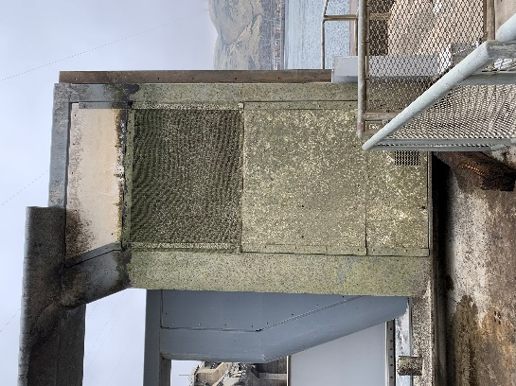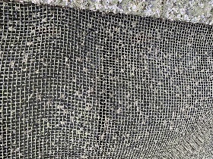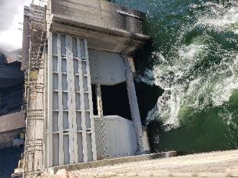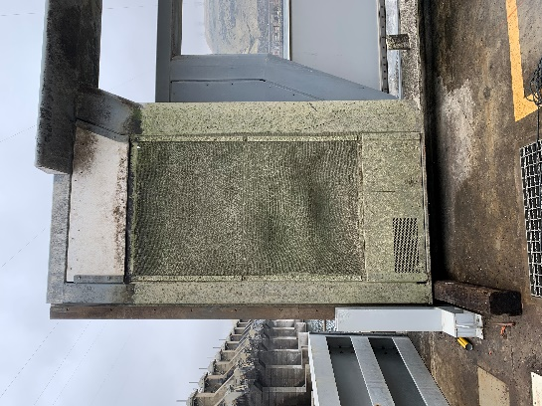

## Project Schedule

Design: FY 2021

Construction: Winter 2021/2022

Evaluation/Closeout: FY 2022

## Current Status

VWW is in place with JBS screen panels (as pictured above) awaiting design and fabrication.

## Topics for FFDRWG Review/Coordination

None currently.

Fish Facility Design Review Work Group (FFDRWG)

USACE, Portland District

Project Update

Date Prepared/Updated: 2021-03-02

# JDA North Fish Ladder LPS water supply upgrade

|  |  |
| --- | --- |
| Project Identifier: | P2 # 492402 |
| Project Manager (PM): | Eric Bluhm (CENWP-PM-FP)  *Eric.V.Bluhm@usace.army.mil* |
| Technical Lead (TL): | Adam White (CENWP-ENC)  *Adam.J.White@usace.army.mil* |
| FFDRWG Coordination (FC): | Jacob Macdonald (CENWP-PME)  *Jacob.Macdonald@usace.army.mil* |

## Project Description

Increase the capacity of the current system.

1. Modify LPS to replace existing drop in well pumps with gravity-fed water supply or alternative, more reliable pump configuration.
2. Larger collection box (current water supply is insufficient so larger box cannot be installed without upgraded water supply.
3. Consider opportunities for volitional passage in the design

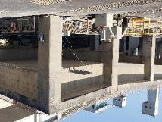 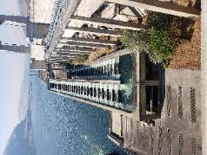 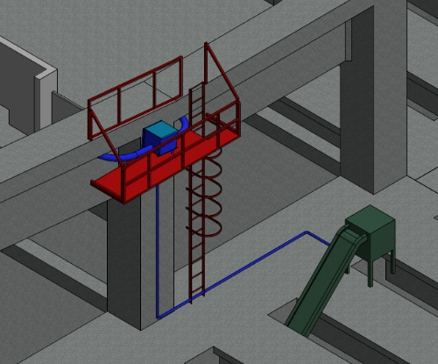

## Project Schedule

Design: FY 2021

Construction: Winter 2021/2022

Evaluation/Closeout: FY 2022

## Current Status

PDT will prepare multiple alternatives for consideration. LPS is in service for 2021 passage season with existing pumps and collection box.

## Topics for FFDRWG Review/Coordination

None currently.

Fish Facility Design Review Work Group (FFDRWG)

USACE, Portland District

Project Update

Date Prepared/Updated: 2021-03-02

# JDA Turbine Rehab

|  |  |
| --- | --- |
| Project Identifier: | P2 # |
| Project Manager (PM): | Steve Sipe (CENWP-PMF-P)  *Steven.C.Sipe@usace.army.mil* |
| Technical Lead (TL): | Curtis Lipski (CENWP-ENC-HD)  *Curtis.L.Lipski@usace.army.mil* |
| FFDRWG Coordination (FL): | Jon Rerecich (CENWP-PME)  *Jonathan.G.Rerecich@usace.army.mil* |

## Project Description

The purpose of this project is to address reliability concerns and maximize production of hydroelectric power at JDA, which includes electrical energy production and electrical grid ancillary services while at the same time, improving survival of fish passing through the turbines. Maximum production of hydroelectric power at JDA will be realized through increased reliability and increased efficiency. Reliability improvements will be realized through a combination of replacement and refurbishment of powertrain equipment to include, but not limited to, turbine runners, shafting, generators, isophase bus, breakers, switches, and transformers. Efficiency improvements will be realized through increased turbine efficiencies associated with new turbine runners and other modifications to the turbines.

The purpose of this project is also to increase survival of turbine passed fish. Increased survival of turbine passed fish will be realized through developing state-of-art hydroelectric turbines to obtain improved fish passage survival through the turbines. The design of the state-of-the-art turbines will be an iterative and collaborative process that focuses on fish-friendly design features and criteria. This iterative and collaborative design process will be similar to the ongoing Ice Harbor L&D turbine runner replacement design and upcoming McNary L&D turbine runner replacement in NWW. Phase 1A recommendations include replacing up to 14 units with combination fixed blade & adjustable blade to obtain improved fish passage survival through the turbines.

## Project Schedule

|  |  |  |
| --- | --- | --- |
| Phase 1 Short Term Schedule | Start | Finish |
| 30% DDR/P&S review | 3/12/2020 | 4/1/2020 |
| 60% DDR/P&S review | 8/28/2020 | 9/18/2020 |
| 90% DDR/P&S review | 9/21/2021 | 2/18/2022 |
| BCOES review | 1/24/2022 | 11/11/2022 |

|  |  |
| --- | --- |
| Overall Schedule Milestones | Date |
| Contract award | October 2024 |
| Collaborative design process Model testing | 2024-2029 |
| First unit installation | 2031-2033 |
| Unit installation complete | 2040-2045 |

## Current Status

* Final VE study report due Feb. 19, 2021
* The 1:25 scale physical observational turbine model rehab and relocation is complete. The model will be used to inform the development of the Phase 1 Plans and Specifications package, to document the hydraulic conditions that affect the biological performance of the existing JDA turbines, and to support the collaborative and iterative design process in Phase 2. ERDC baseline model validation testing with the existing runner has been scheduled for last week and this week. Baseline model data collection for Test Series 1 will be occurring until May 2021 at which time ERDC is scheduled to transition back to McNary. This task includes preparation of a data report documenting the runs performed, results, conclusions, and recommendations. Runner evaluation tests will need to carry over to Test Series 2 (not yet scoped), which is expected to occur in late 2021 or early 2022.
* Tailrace flow patterns have been validated in the 1:45 JDA general model and in a CFD model. Model runs will commence after further HAC modeling is complete and preliminary options for the turbine mix are established. The focus of the tailrace modeling will be to assess juvenile egress and conditions for adult approach to the fish ladder entrances.

## Topics for FFDRWG Review/Coordination

None currently.

Fish Facility Design Review Work Group (FFDRWG)

USACE, Portland District

Project Update

Date Prepared/Updated: 2021-03-02

# TDA AWS trash rake

|  |  |
| --- | --- |
| Project Identifier: | P2 # |
| Project Manager (PM): | Ida Royer (CENWP-PMF)  *Ida.M.Royer@usace.army.mil* |
| Technical Lead (TL): | Erica Tarbox (CENWP-ENC)  *Erica.M.Tarbox@usace.army.mil* |
| FFDRWG Coordination (FC): | Ida Royer (CENWP-PMF)  *Ida.M.Royer@usace.army.mil* |

## Project Description

## This project is to evaluate alternatives to remove debris from The Dalles Dam Auxiliary Water Supply (AWS) trash rack. Debris build-up on the rack currently causes high head differential across the rack.

## Project Schedule

TBD

## Current Status

New Startup. PM and TL have been assigned. Kickoff meeting and site visit are being scheduled and team members are being assigned.

## Topics for FFDRWG Review/Coordination

None currently. PDT will solicit FFDRWG review during the Engineering Design Report (EDR) process.

Fish Facility Design Review Work Group (FFDRWG)

USACE, Portland District

Project Update

Date Prepared/Updated: 2021-03-01

# BON Spillway Rock Removal [prevention]

|  |  |
| --- | --- |
| Project Identifier: | P2 # 470163 |
| Project Manager (PM): | Jeremiah Woodard (CENWP-PMF-P)  *Jeremiah.J.Woodard@usace.army.mil* |
| Technical Lead (TL): | Christopher Motti (CENWP-ENC-HD)  *Christopher.S.Motti@usace.army.mil* |
| FFDRWG Coordination (FC): | Ida Royer / Andrew Derugin (CENWP-PME)  [*Ida.M.Royer@usace.army.mil*](mailto:Ida.M.Royer@usace.army.mil) */ Andrew.G.Derugin@usace.army.mil* |

## Project Description

This project is to determine whether a structural alternative can be identified to prevent rocks from moving into the stilling basin of Bonneville Dam. Currently emergency contracts are placed most years (four out of five since 2011) to physically remove rocks from the stilling basin. Alternatives will be evaluated based on factors such as their ability to prevent rock movement, cost, and ease of construction.

## Project Schedule

A Phase IA report is scheduled to be completed at the end of September 2021.

## Current Status

CFD modeling, ERDC physical modeling are complete. The modeling results are still being analyzed and formed into a modeling report. A funding gap (that is now resolved) limited progress since the last FFDRWG update but the project is back on track now.

## Topics for FFDRWG Review/Coordination

None currently.

Fish Facility Design Review Work Group (FFDRWG)

USACE, Portland District

Project Update

Date Prepared/Updated: 2021-03-02

# BON Second Powerhouse FGE

|  |  |
| --- | --- |
| Project Identifier: | P2 # |
| Project Manager (PM): | Jim Adams (CENWP-PMF)  *James.R.Adams@usace.army.mil* |
| Technical Lead (TL): | Bridget Bell (CENWP-ENC)  *Bridget.M.Bell@usace.army.mil* |
| FFDRWG Coordination (FL): | Jon Rerecich (CENWP-PME)  *Jonathan.G.Rerecich@usace.army.mil* |

## Project Description

Steel plates were installed in all units in the A and B gatewells to restrict flow. During routine inspections, however, it became apparent that the anchoring system for the steel plates was inadequate. In effect, the nuts and anchoring bolts holding down the plates had come lose, posing the risk that the plates could detach and potentially take out a unit. All flow restriction plates were removed from the units.

A concrete corbel will be installed in the same location as the flow control plates with the design goal to achieve similar gatewell hydraulic conditions as the flow control plates. This new concrete corbel has been designed to meet the flow criteria established and tested for the previous flow restrictor plates to meet the hydraulic and biological goals.

## Project Schedule

* Awarded 21 December 2020 to Northbank Civil and Marine. Notice to proceed 29 December 2020.

|  |  |  |  |  |
| --- | --- | --- | --- | --- |
| CLIN | Status | Description | Award/Exercise Date | Construction Execution Window |
| 1 | Mandatory | Mobilization/Demobilization | December 2020 Award |  |
| 2 | Mandatory | Unit 15 Construction | December 2020 Award | February 2021-April 2021 |
| 3 | Optional | Second Mob/Demob and Unit 11 Construction | Sept. 30, 2021 | Dec 2021-Feb 2022 |
| 4 | Optional | 2 Additional Units | Sept. 30, 2021 | Extend through May 2022 |
| 5 | Optional | 2 Additional Units | Nov. 30, 2021 | Extend through August 2022 |
| 6 | Optional | 2 Additional Units (Unit 18 + 1 more Unit) | Nov. 30, 2021 | Extend through February 2023 |

* Construction in unit 15 to be in early spring of 2021. Unit 15 is on the outage schedule March 1-April 20. The contract states the unit must be completed by April 15th.
* Hydraulic Testing Spring 2021 – dependent on flows. We plan to be ready for testing by as early

as mid-May. The A/E testing contract is expected to be awarded soon. A more detailed test schedule will follow.

* Evaluation of testing results late summer 2021. We expect to be able to move on to additional units starting in the late fall of 2021 if the testing results prove acceptable.

## Current Status

2021 Fish Passage Plan, Draft Appendix A, contains the special operations for hydraulic testing. More details on the schedule and calendar dates will be provided as we coordinate with the contractor and get closer to testing.

## Topics for FFDRWG Review/Coordination

None currently. Testing results will be reviewed with FFDRWG in late summer 2021 to determine if hydraulic objectives have been met.

Fish Facility Design Review Work Group (FFDRWG)

USACE, Portland District

Project Update

Date Prepared/Updated: 2021-03-03

# BON Lamprey Passage Structure Pump Upgrade

|  |  |
| --- | --- |
| Project Identifier: | P2 # 492400 (BON1) and 492401 (BON2) |
| Project Manager (PM): | Bob Winters (CENWP-PM-FP)  *Robert.Winters@usace.army.mil* |
| Technical Lead (TL): | Ben Hausmann (CENWP-ODB)  *Benjamin.J.Hausmann@usace.army.mil* |
| FFDRWG Coordination (FC): | Andrew Derugin (CENWP-PME)  *Andrew.G.Derugin@usace.army.mil* |

## Project Description

Bradford Island, Cascades Island, and Washington Shore LPS's will have current drop in well pumps replaced with standardized 480V surface mount pumps that will increase the reliability and flexibility of the Bonneville Dam LPS system.

## Project Schedule

* Acquire Materials: FY 2021
* Installation: WA Shore and Cascades Island – FY 2021, Bradford Island – Winter 2021/2022
* Evaluation/Closeout: FY 2022

## Current Status

Project staff are ordering pumps and will install them upon delivery. Delivery expected the end of next week.

## Topics for FFDRWG Review/Coordination

None currently.

Fish Facility Design Review Work Group (FFDRWG)

USACE, Portland District

Project Update

Date Prepared/Updated: 2021-03-03

# BON Cascades Island LPS Flume modifications

|  |  |
| --- | --- |
| Project Identifier: | P2 # 492401 |
| Project Manager (PM): | Bob Winters (CENWP-PM-FP)  *Robert.Winters@usace.army.mil* |
| Technical Lead (TL): | Adam White (CENWP-ENC)  *Adam.J.White@usace.army.mil* |
| FFDRWG Coordination (FC): | Andrew Derugin (CENWP-PME)  *Andrew.G.Derugin@usace.army.mil* |

## Project Description

Lamprey flume needs to be lowered to eliminate the mid-system lift pumps. This may require rerouting existing plumbing and moving electrical equipment in the area, as well as fabricating new brackets and a new flume section.

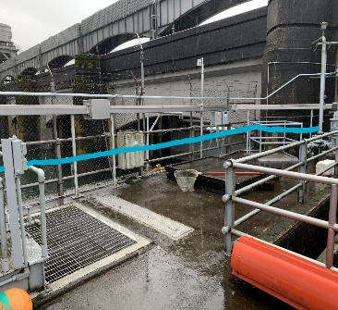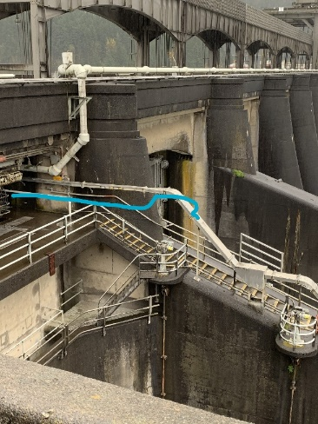

## Project Schedule

* Design: FY 2021
* Construction: FY 2021 (or FY 2022)
* Evaluation and Closeout: FY 2022

## Current Status

Initiating design.

## Topics for FFDRWG Review/Coordination

None currently.

Fish Facility Design Review Work Group (FFDRWG)

USACE, Portland District

Project Update

Date Prepared/Updated: 2021-03-03

# BON Cascades Island upper picketed lead modification

|  |  |
| --- | --- |
| Project Identifier: | P2 # 492401 |
| Project Manager (PM): | Bob Winters (CENWP-PM-FP)  *Robert.Winters@usace.army.mil* |
| Technical Lead (TL): | Ben Hausmann (CENWP-ODB)  *Benjamin.J.Hausmann@usace.army.mil* |
| FFDRWG Coordination (FC): | Andrew Derugin (CENWP-PME)  *Andrew.G.Derugin@usace.army.mil* |

## Project Description

Modify two upper picket leads (upstream of new LPS trap) to exclude lamprey from AWS Channel. Replace existing leads with smaller mesh and eliminate gaps to prevent lamprey from straying into the dead-end abandoned AWS channel.

## Project Schedule

* Installation: February 2021
* Evaluation/Closeout: FY 2021

## Current Status

OD-B project staff are scheduled to perform this minor modification while the ladder is dewatered for maintenance through February 2021.

## Topics for FFDRWG Review/Coordination

None currently.

Fish Facility Design Review Work Group (FFDRWG)

USACE, Portland District

Project Update

Date Prepared/Updated: 2021-03-03

# BON Washington Shore control section redesign

|  |  |
| --- | --- |
| Project Identifier: | P2 # 492401 |
| Project Manager (PM): | Bob Winters (CENWP-PM-FP)  *Robert.Winters@usace.army.mil* |
| Technical Lead (TL): | Shari Dunlop (CENWP-ENC)  *Shari.L.Dunlop@usace.army.mil* |
| FFDRWG Coordination (FC): | Andrew Derugin (CENWP-PME)  *Andrew.G.Derugin@usace.army.mil* |

## Project Description

Modify the serpentine-style flow control section of Bonneville Dam’s Washington Shore fish ladder, converting it to an Ice Harbor-style vertical slot with submerged orifice configuration. See CRSO EIS §7.6.2.17.

## Project Schedule

TBD

## Current Status

New Startup. PM and TL have been assigned. Kickoff meeting March 2021.

## Topics for FFDRWG Review/Coordination

The current PIT tag antennas will not work with the new design.

Fish Facility Design Review Work Group (FFDRWG)

USACE, Portland District

Project Update

Date Prepared/Updated: 2021-03-03

# BON Bradford Island Ladder extensive minor modifications to serpentine section for lamprey

|  |  |
| --- | --- |
| Project Identifier: | P2 # 492400 |
| Project Manager (PM): | Bob Winters (CENWP-PM-FP)  *Robert.Winters@usace.army.mil* |
| Technical Lead (TL): | Adam White (CENWP-ENC)  *Adam.J.White@usace.army.mil* |
| FFDRWG Coordination (FC): | Andrew Derugin (CENWP-PME)  *Andrew.G.Derugin@usace.army.mil* |

## Project Description

Extensive minor modifications to control section (serpentine weirs) of ladder including refuge boxes, rounded corners on weirs, additional lamprey orifices, and (if practicable) new features such as artificial rocks.

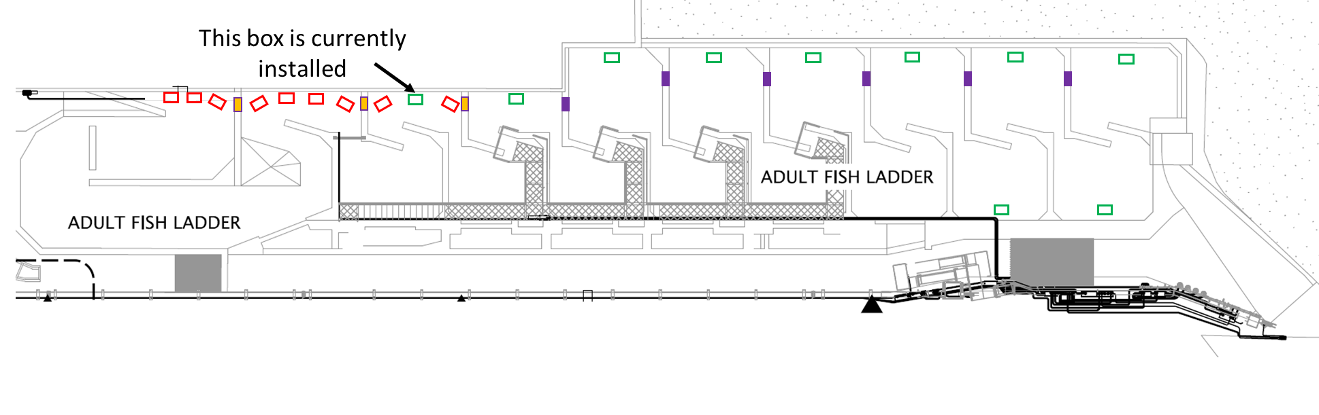 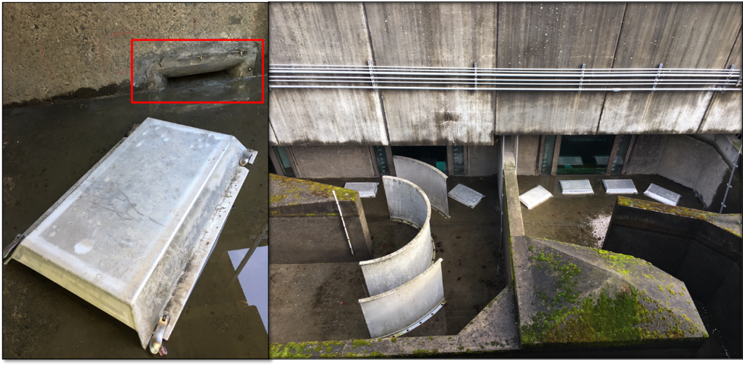

## Project Schedule

TBD

## Current Status

New Startup.

## Topics for FFDRWG Review/Coordination

None currently.

Fish Facility Design Review Work Group (FFDRWG)

USACE, Portland District

Project Update

Date Prepared/Updated: 2021-03-03

# BON Bradford Island B-Branch entrance improvements (variable width entrance weir, bollards, and transition pool LPS)

|  |  |
| --- | --- |
| Project Identifier: | P2 # 492400 |
| Project Manager (PM): | Bob Winters (CENWP-PM-FP)  *Robert.Winters@usace.army.mil* |
| Technical Lead (TL): | Adam White (CENWP-ENC)  *Adam.J.White@usace.army.mil* |
| FFDRWG Coordination (FC): | Andrew Derugin (CENWP-PME)  *Andrew.G.Derugin@usace.army.mil* |

## Project Description

Design B-Branch (Spillway) entrance improvements, including variable width weir, bollards, refuge boxes or other cover, as feasible. Implement in conjunction with transition pool LPS at this fishway.

* Modeled after Cascades Island and JDA North (mirror image of Cascades Island Entrance)

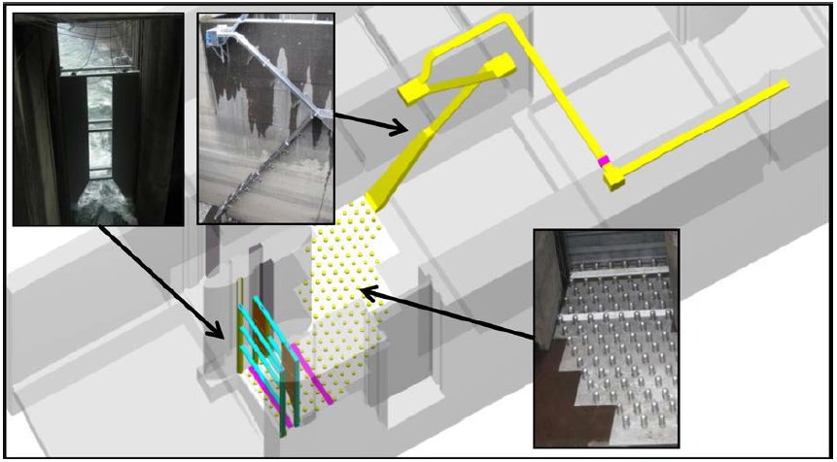

*Cascades Island entrance improvements (2009)*

## Project Schedule

TBD

## Current Status

New Startup.

## Topics for FFDRWG Review/Coordination

None currently.

Fish Facility Design Review Work Group (FFDRWG)

USACE, Portland District

Project Update

Date Prepared/Updated: 2021-03-03

# BON Washington Shore transition pool LPS

|  |  |
| --- | --- |
| Project Identifier: | P2 # 492401 |
| Project Manager (PM): | Bob Winters (CENWP-PM-FP)  *Robert.Winters@usace.army.mil* |
| Technical Lead (TL): | Adam White (CENWP-ENC)  *Adam.J.White@usace.army.mil* |
| FFDRWG Coordination (FC): | Andrew Derugin (CENWP-PME)  *Andrew.G.Derugin@usace.army.mil* |

## Project Description

Design Transition Pool LPS to tailrace deck collection box.

CRSO EIS§7.6.2.20 : “Ramp-like flume structures would be installed or modified in fish ladders at Bonneville, The Dalles, and John Day dams to guide adult lamprey out of fish ladders and into parallel systems for volitional passage or collection for upstream transport or passage studies. The LPSs would use independent water sources (pumps or gravity-flow systems) and may be placed in various locations within fish ladders, such as collection channels, junction pools, or auxiliary water supply channels.

## Project Schedule

* Design: FY 2021 – FY 2022
* Construction: Winter 2022/2023
* Evaluation/Closeout: FY 2023

## Current Status

New Startup.

## Topics for FFDRWG Review/Coordination

None currently.

Fish Facility Design Review Work Group (FFDRWG)

USACE, Portland District

Project Update

Date Prepared/Updated: 2021-03-03

# TDA East Fish Ladder transition pool LPS

|  |  |
| --- | --- |
| Project Identifier: | P2 # 492403 |
| Project Manager (PM): | Eric Bluhm (CENWP-PM-FP)  *Eric.V.Bluhm@usace.army.mil* |
| Technical Lead (TL): | Adam White (CENWP-ENC)  *Adam.J.White@usace.army.mil* |
| FFDRWG Coordination (FC): | Jacob Macdonald (CENWP-PME)  *Jacob.Macdonald@usace.army.mil* |

## Project Description

Design Transition Pool LPS to tailrace deck collection box.

CRSO EIS§7.6.2.20 : “Ramp-like flume structures would be installed or modified in fish ladders at Bonneville, The Dalles, and John Day dams to guide adult lamprey out of fish ladders and into parallel systems for volitional passage or collection for upstream transport or passage studies. The LPSs would use independent water sources (pumps or gravity-flow systems) and may be placed in various locations within fish ladders, such as collection channels, junction pools, or auxiliary water supply channels.

## Project Schedule

* Design: FY 2021 – FY 2022
* Construction: Winter 2022/2023
* Evaluation/Closeout: FY 2023

## Current Status

New Startup.

## Topics for FFDRWG Review/Coordination

None currently.

Fish Facility Design Review Work Group (FFDRWG)

USACE, Portland District

Project Update

Date Prepared/Updated: 2021-03-03

# TDA East Fish Ladder control section weir modifications for lamprey

|  |  |
| --- | --- |
| Project Identifier: | P2 # 492403 |
| Project Manager (PM): | Eric Bluhm (CENWP-PM-FP)  *Eric.V.Bluhm@usace.army.mil* |
| Technical Lead (TL): | Adam White (CENWP-ENC)  *Adam.J.White@usace.army.mil* |
| FFDRWG Coordination (FC): | Jacob Macdonald (CENWP-PME)  *Jacob.Macdonald@usace.army.mil* |

## Project Description

Modify elevated orifices in East Fish Ladder control section weirs 154-157 for better adult lamprey passage.

## Project Schedule

* Design: FY 2022
* Construction: Winter 2022/2023
* Evaluation/Closeout: FY 2023

## Current Status

New Startup.

## Topics for FFDRWG Review/Coordination

None currently.

Fish Facility Design Review Work Group (FFDRWG)

USACE, Portland District

Project Update

Date Prepared/Updated: 2021-03-03

# JDA South Ladder entrance improvements (rounded crest, slot filler)

|  |  |
| --- | --- |
| Project Identifier: | P2 # 492402 |
| Project Manager (PM): | Eric Bluhm (CENWP-PM-FP)  *Eric.V.Bluhm@usace.army.mil* |
| Technical Lead (TL): | Adam White (CENWP-ENC)  *Adam.J.White@usace.army.mil* |
| FFDRWG Coordination (FC): | Jacob Macdonald (CENWP-PME)  *Jacob.Macdonald@usace.army.mil* |

## Project Description

Entrance weir improvements (rounded crest, slot filler). Caps cannot be added to South Ladder entrance weir due to FPP submergence criteria so the weir needs to be modified more extensively to provide rounded weir crests and guide slot covers.

## Project Schedule

* Design: FY2021
* Construction: Winter 2021/2022
* Evaluation/Closeout: FY 2022

## Current Status

New Startup.

## Topics for FFDRWG Review/Coordination

None currently.